UNITED STATES
SECURITIES AND EXCHANGE COMMISSION
WASHINGTON, D.C. 20549
________________________________________________________
FORM 8-K
________________________________________________________
CURRENT REPORT
Pursuant to Section 13 or 15(d) of the Securities Exchange Act of 1934
Date of Report (Date of earliest event reported): August 4, 2026
________________________________________________________
CIPHER DIGITAL INC.
(Exact name of Registrant as Specified in Its Charter)
________________________________________________________
Delaware |  |  | 001-39625 |  |  | 85-1614529
(State or Other Jurisdiction  of Incorporation) |  |  | (Commission File Number) |  |  | (IRS Employer  Identification No.)
1 Vanderbilt Avenue
Floor 54
New York, New York |  |  |  |  |  | 10017
(Address of Principal Executive Offices) |  |  |  |  |  | (Zip Code)
Registrant’s Telephone Number, Including Area Code: (332) 262-2300
N/A
(Former Name or Former Address, if Changed Since Last Report)
________________________________________________________
Check the appropriate box below if the Form 8-K filing is intended to simultaneously satisfy the filing obligation of the registrant under any of the following provisions:
o |  |  | Written communications pursuant to Rule 425 under the Securities Act (17 CFR 230.425)
o |  |  | Soliciting material pursuant to Rule 14a-12 under the Exchange Act (17 CFR 240.14a-12)
o |  |  | Pre-commencement communications pursuant to Rule 14d-2(b) under the Exchange Act (17 CFR 240.14d-2(b))
o |  |  | Pre-commencement communications pursuant to Rule 13e-4(c) under the Exchange Act (17 CFR 240.13e-4(c))
Securities registered pursuant to Section 12(b) of the Act:
Title of each class |  |  |  |  |  | Trading  Symbol(s) |  |  |  |  |  | Name of each exchange on which registered
Common Stock, par value $0.001 per share |  |  |  |  |  | CIFR |  |  |  |  |  | The Nasdaq Stock Market LLC
Indicate by check mark whether the registrant is an emerging growth company as defined in Rule 405 of the Securities Act of 1933 (§ 230.405 of this chapter) or Rule 12b-2 of the Securities Exchange Act of 1934 (§ 240.12b-2 of this chapter).
Emerging growth company o
If an emerging growth company, indicate by check mark if the registrant has elected not to use the extended transition period for complying with any new or revised financial accounting standards provided pursuant to Section 13(a) of the Exchange Act. o

Item 2.02 Results of Operations and Financial Condition.
On August 4, 2026, Cipher Digital Inc. (the “Company”) announced its results for the second quarter ended June 30, 2026. The full text of the press release issued in connection with the announcement is furnished as Exhibit 99.1 to this Current Report on Form 8-K (the “Report”).

Item 7.01 Regulation FD Disclosure.
On August 4, 2026, the Company posted a presentation to its website at https://investors.cipherdigital.com (the “Presentation”). A copy of the Presentation is furnished as Exhibit 99.2 to this Report. The Company expects to use the Presentation, in whole or in part, and possibly with modifications, in connection with the earnings call with investors, analysts and others.
The information contained in the Presentation is summary information that is intended to be considered in the context of the Company’s Securities and Exchange Commission (“SEC”) filings and other public announcements that the Company may make, by press release or otherwise, from time to time. The Presentation speaks only as of the date of this Report. The Company undertakes no duty or obligation to publicly update or revise the information contained in the Presentation, although it may do so from time to time. Any such updating may be made through the filing of other reports or documents with the SEC, through press releases or through other public disclosure. In addition, the exhibit furnished herewith contains statements intended as “forward-looking statements” that are subject to the cautionary statements about forward-looking statements set forth in such exhibit. By furnishing the information contained in the Presentation, the Company makes no admission as to the materiality of any information in the Presentation that is required to be disclosed solely by reason of Regulation FD.
The information in Items 2.02 and 7.01 of this Report (including Exhibits 99.1 and 99.2 attached hereto) shall not be deemed “filed” for purposes of Section 18 of the Securities Exchange Act of 1934, as amended (the “Exchange Act”), or otherwise subject to the liabilities of that section, nor shall it be deemed incorporated by reference in any filing under the Securities Act of 1933, as amended, or the Exchange Act, except as expressly provided by specific reference in such a filing.

Item 9.01 Financial Statements and Exhibits.
(d)Exhibits.
The following exhibits related to Item 2.02 and Item 7.01 shall be deemed to be furnished, and not filed:
Exhibit  Number |  |  |  |  |  | Description
99.1 |  |  |  |  |  | Press Release of the Company, dated August 4, 2026
99.2 |  |  |  |  |  | Presentation of the Company, dated August 4, 2026
104 |  |  |  |  |  | Cover Page Interactive Data File (embedded within the Inline XBRL document)

SIGNATURES
Pursuant to the requirements of the Securities Exchange Act of 1934, the registrant has duly caused this report to be signed on its behalf by the undersigned hereunto duly authorized.
 |  |  |  |  |  |  |  |  | Cipher Digital Inc.
Date: |  |  | August 4, 2026 |  |  | By: |  |  | /s/ Tyler Page
Tyler Page
Chief Executive Officer

Exhibit 99.1
Cipher Digital Provides Second Quarter 2026 Business Update
Black Pearl Data Center Delivery Accelerated
Acquired Option for 900 MW Site Near San Antonio, Texas
Completed Project-Level Financing to Fully Fund Third Data Center Development

NEW YORK—August 4, 2026—Cipher Digital Inc. (NASDAQ: CIFR) (“Cipher” or the “Company”), a leading developer, owner, and operator of industrial-scale data centers, today announced its second quarter 2026 financial results, with an update on its operations and business strategy.
As part of this update, Cipher disclosed an amendment to its Black Pearl campus lease with its investment-grade hyperscale tenant, accelerating the development timeline of initial capacity at the tenant's request. Under the amended terms, Cipher began delivering data center capacity at the beginning of August, two months ahead of the original schedule.
“We are proud to have delivered our first HPC data center capacity ahead of schedule and announce that rent has commenced at the site,” said Tyler Page, Chief Executive Officer. “This accelerated delivery proves we can execute at scale, with speed, and without compromise in a challenging environment. As we continue to acquire new sites and sign new deals, our foundation of disciplined execution is what truly sets us apart.”
Cipher also today announced it has acquired an option on a new site called Apollo for up to 900 MW, located within 25 miles of San Antonio, Texas. The site spans approximately 288 acres and has been submitted as a studied load in Batch Zero through ERCOT's updated process. The site's flat, buildable terrain makes it well-suited for large-scale data center development, and its proximity to San Antonio positions it favorably for fiber connectivity. Cipher moved quickly to secure the option, reflecting the Company's ability to identify and act on attractive opportunities as they arise in the market.
In the second quarter, the Company also built on strong momentum from previous quarters by completing another highly successful bond offering. The offering fully funded the Company’s Stingray development through substantial completion and reimbursed Cipher for $56.7 million of previously funded project expenditures.
“A core strength of our strategy is its repeatability, and in the second quarter, we demonstrated that once again. We accessed capital markets to fund another one of our leases, secured an option on a new site, and delivered accelerated capacity to our tenant, further building our position as a leading HPC development platform," said Tyler Page. “We look forward to carrying this momentum into the third quarter, where we expect to make significant additional progress.”
Finance and Operations Highlights
•First data center capacity at Black Pearl delivered in August, with rent commenced
•Secured option for new Apollo data center site with up to 900 MW near San Antonio, Texas
•Completed bond offering to fully fund Stingray data center development
•Barber Lake data center continues to progress towards completion as tenant has commenced beneficial use of the facility, including partial occupancy of the building and deployment of network racks
•Black Pearl data center continues to progress towards completion with remaining Phase I data halls moving through MEP fit-out and Phase II concrete foundations, building steel, and underground electrical in progress
•Stingray data center construction continues to progress on schedule, with earthwork, grading, pad preparation, and underground electrical work all underway
•Q2 2026 Revenue of $25 million and Adjusted EBITDA of negative $30 million

Business Update Call and Webcast

The live webcast and a webcast replay of the conference call can be accessed from the investor relations section of Cipher’s website at https://investors.cipherdigital.com/.

About Cipher
Cipher develops and operates industrial-scale data centers engineered for next-generation computing at the highest standards of innovation, precision, and excellence. The Company brings together deep expertise across power sourcing, construction, engineering, operations, real estate, and technology to deliver high-quality data centers purpose built for HPC workloads. By partnering with premier tenants, Cipher seeks to meet the growing demand for industrial-scale data center capacity and become a leading HPC development platform that is built for hyperscale. To learn more about Cipher, please visit https://www.cipherdigital.com/.

Forward Looking Statements
This press release contains certain forward-looking statements within the meaning of the federal securities laws of the United States. The Company intends such forward-looking statements to be covered by the safe harbor provisions for forward-looking statements contained in the Private Securities Litigation Reform Act of 1995 and includes this statement for purposes of complying with these safe harbor provisions. Any statements made in this press release that are not statements of historical fact, such as, statements about the Company’s beliefs and expectations regarding its future results of operations and financial position, its planned business model and strategy, its data center development, timing and likelihood of success, capacity, functionality and timing of operation of data centers, expectations regarding the operations of data centers, potential strategic initiatives, such as joint ventures and partnerships, and management plans and objectives, are forward-looking statements and should be evaluated as such. These forward-looking statements generally are identified by the words “may,” “will,” “should,” “expects,” “plans,” “anticipates,” “could,” “seeks,” “intends,” “targets,” “projects,” “contemplates,” “believes,” “estimates,” “strategy,” “future,” “forecasts,” “opportunity,” “predicts,” “potential,” “would,” “will likely result,” “continue,” and similar expressions (including the negative versions of such words or expressions).
These forward-looking statements are based upon estimates and assumptions that, while considered reasonable by Cipher and its management, are inherently uncertain. Such forward-looking statements are subject to risks, uncertainties, and other factors that could cause actual results to differ materially from those expressed or implied by such forward-looking statements. New risks and uncertainties may emerge from time to time, and it is not possible to predict all risks and uncertainties. Many factors could cause actual future events to differ materially from the forward-looking statements in this press release, including but not limited to: volatility in the price of Cipher’s securities due to a variety of factors, including changes in the competitive and regulated industry in which Cipher operates, Cipher’s evolving business model and strategy and efforts it may make to modify aspects of its business model or engage in various strategic initiatives, variations in performance across competitors, changes in laws and regulations affecting Cipher’s business, and the ability to implement business plans, forecasts, and other expectations and to identify and realize additional opportunities. The foregoing list of factors is not exhaustive. You should carefully consider the foregoing factors and the other risks and uncertainties described in the “Risk Factors” section of Cipher’s Annual Report on Form 10-K for the fiscal year ended December 31, 2025 filed with the Securities and Exchange Commission (“SEC”) on February 24, 2026, Cipher’s Quarterly Report on Form 10-Q for the quarterly period ended June 30, 2026 to be filed with the SEC, and in Cipher’s subsequent filings with the SEC. These filings identify and address other important risks and uncertainties that could cause actual events and results to differ materially from those contained in the forward-looking statements. Forward-looking statements speak only as of the date they are made. Readers are cautioned not to put undue reliance on forward-looking statements, and Cipher assumes no obligation and, except as required by law, does not intend to update or revise these forward-looking statements, whether as a result of new information, future events, or otherwise.
The Company maintains a dedicated investor website at https://investors.cipherdigital.com/investors (“Investors’ Website”). Financial and other important information regarding the Company is routinely posted on and accessible through the Investors Website. Cipher uses its Investors’ Website as a distribution channel of material information about the Company, including through press releases, investor presentations, reports and notices of upcoming events. Cipher intends to utilize its Investors’ Website as a channel of distribution to reach public investors and as a

means of disclosing material non-public information for complying with disclosure obligations under Regulation FD. In addition, you may sign up to automatically receive email alerts and other information about the Company by visiting the “Email Alerts” option under the Investors Resources section of Cipher’s Investors’ Website and submitting your email address.

Non-GAAP Financial Measures
This press release includes supplemental financial measures Adjusted EBITDA, that excludes the impact of (i) interest income, (ii) interest expense, (iii) income taxes, (iv) depreciation and amortization, (v) the non-cash change in fair value of derivative asset, (vi) share-based compensation expense, (vii) nonrecurring gains and losses, (viii) the non-cash change in fair value of warrant liability, (ix) non-cash losses related to miners reclassified as held for sale, (x) impairment of long-lived assets, and (xi) non-cash disposal of miners.
Beginning with the three months ended March 31, 2026, the Company changed its primary non-GAAP performance from "Adjusted Earnings (Loss)" to Adjusted EBITDA. Adjusted EBITDA differs from Adjusted Earnings (Loss) only in that, in addition to the adjustments previously made to compute Adjusted Earnings (Loss), Adjusted EBITDA also excludes interest expense, interest income, and current income tax expense. We believe Adjusted EBITDA is more representative of the Company's core operating performance, more comparable to measures used by industry peers, and more useful to investors evaluating our underlying business. The reconciliation table below presents Adjusted EBITDA for both periods presented under the Company’s new methodology. The Company does not intend to report Adjusted Earnings (Loss) in future periods.
These supplemental financial measures are not measurements of financial performance under accounting principles generally accepted in the United States (“GAAP”) and, as a result, these supplemental financial measures may not be comparable to similarly titled measures of other companies. Management uses these non-GAAP financial measures internally to help understand, manage, and evaluate our business performance and to help make operating decisions. We believe the use of these non-GAAP financial measures can also facilitate comparison of our operating results to those of our competitors by excluding certain items that vary in our industry based on company policy.
Non-GAAP financial measures are subject to material limitations as they are not in accordance with, or a substitute for, measurements prepared in accordance with GAAP. For example, we expect that share-based compensation expense, which is excluded from the non-GAAP financial measure, will continue to be a significant recurring expense over the coming years and is an important part of the compensation provided to certain employees, officers and directors. Similarly, we expect that depreciation and amortization will continue to be a recurring expense over the term of the useful life of the related assets. Our non-GAAP financial measures are not meant to be considered in isolation and should be read only in conjunction with our condensed consolidated financial statements, which have been prepared in accordance with GAAP. We rely primarily on such condensed consolidated financial statements to understand, manage and evaluate our business performance and use the non-GAAP financial measures only supplementally.

Contacts:

Investor Contact:
Courtney Knight
Head of Investor Relations at Cipher Digital
courtney.knight@cipherdigital.com

Media Contact:
Ryan Dicovitsky
Dukas Linden Public Relations

CipherDigital@DLPR.com

CIPHER DIGITAL INC.
CONDENSED CONSOLIDATED BALANCE SHEETS
(in thousands, except for share and per share amounts)
(unaudited)
 |  |  | June 30, 2026 |  |  |  |  |  | December 31, 2025
ASSETS
Current assets
Cash and cash equivalents |  |  | $ 831,829 |  |  |  |  |  | $ 628,263
Restricted cash, current |  |  | 3,188,452 |  |  |  |  |  | 1,761,292
Accounts receivable |  |  | 20,084 |  |  |  |  |  | 687
Receivables, related party |  |  | - |  |  |  |  |  | 271
Prepaid expenses and other current assets |  |  | 34,477 |  |  |  |  |  | 7,977
Bitcoin |  |  | 37,802 |  |  |  |  |  | 125,400
Miners held for sale |  |  | - |  |  |  |  |  | 94,879
Derivative asset, current |  |  | 19,436 |  |  |  |  |  | 34,090
Total current assets |  |  | 4,132,080 |  |  |  |  |  | 2,652,859
Restricted cash, noncurrent |  |  | 539,506 |  |  |  |  |  | 275,076
Property and equipment, net |  |  | 2,132,585 |  |  |  |  |  | 633,417
Intangible assets, net |  |  | 76,929 |  |  |  |  |  | 77,388
Investment in equity investees |  |  | - |  |  |  |  |  | 29,400
Derivative asset, non-current |  |  | 3,244 |  |  |  |  |  | 22,720
Operating lease right-of-use asset |  |  | 36,212 |  |  |  |  |  | 11,321
Security deposits |  |  | 27,489 |  |  |  |  |  | 27,732
Other noncurrent assets |  |  | 553,409 |  |  |  |  |  | 561,995
Total assets |  |  | $ 7,501,454 |  |  |  |  |  | $ 4,291,908
LIABILITIES, REDEEMABLE NONCONTROLLING INTEREST, AND STOCKHOLDERS’ EQUITY
Current liabilities
Accounts payable |  |  | $ 289,091 |  |  |  |  |  | $ 40,064
Accrued expenses and other current liabilities |  |  | 356,746 |  |  |  |  |  | 90,086
Finance lease liability, current portion |  |  | 4,475 |  |  |  |  |  | 4,237
Operating lease liability, current portion |  |  | 2,242 |  |  |  |  |  | 1,731
Warrant liability |  |  | 632,060 |  |  |  |  |  | 525,160
Short-term borrowings |  |  | 94,484 |  |  |  |  |  | 37,793
Total current liabilities |  |  | 1,379,098 |  |  |  |  |  | 699,071
Deferred revenue |  |  | 25,512 |  |  |  |  |  | -
Long-term borrowings, net |  |  | 5,446,866 |  |  |  |  |  | 2,711,648
Asset retirement obligations |  |  | 23,509 |  |  |  |  |  | 33,696
Finance lease liability |  |  | 795 |  |  |  |  |  | 3,094
Operating lease liability |  |  | 37,938 |  |  |  |  |  | 8,545

Total liabilities |  |  | 6,913,718 |  |  |  |  |  | 3,456,054
Commitments and contingencies (Note 13)
Redeemable noncontrolling interest |  |  | 25,679 |  |  |  |  |  | 30,319
Stockholders’ equity
Preferred stock, $0.001 par value; 10,000,000 shares authorized, none issued and outstanding as of June 30, 2026, and December 31, 2025 |  |  | - |  |  |  |  |  | -
Common stock, $0.001 par value, 1,000,000,000 and 1,000,000,000 shares authorized as of June 30, 2026 and December 31, 2025, respectively, 423,575,369 and 412,074,529 shares issued as of June 30, 2026 and December 31, 2025, respectively, and 414,253,564 and 404,963,061 shares outstanding as of June 30, 2026, and December 31, 2025, respectively |  |  | 424 |  |  |  |  |  | 412
Additional paid-in capital |  |  | 1,947,143 |  |  |  |  |  | 1,808,786
Accumulated deficit |  |  | (1,385,501) |  |  |  |  |  | (1,003,656)
Treasury stock, at par, 9,321,805 and 7,111,468 shares at June 30, 2026 and December 31, 2025, respectively |  |  | (9) |  |  |  |  |  | (7)
Total stockholders’ equity |  |  | 562,057 |  |  |  |  |  | 805,535
Total liabilities, redeemable noncontrolling interest, and stockholders’ equity |  |  | $ 7,501,454 |  |  |  |  |  | $ 4,291,908

CIPHER DIGITAL INC.
CONDENSED CONSOLIDATED STATEMENTS OF OPERATIONS
(in thousands, except for share and per share amounts)
(unaudited)

 |  |  | Three Months Ended June 30, |  |  |  |  |  |  |  |  |  |  |  | Six Months Ended June 30,
 |  |  | 2026 |  |  |  |  |  | 2025 |  |  |  |  |  | 2026 |  |  |  |  |  | 2025
Revenue - bitcoin mining |  |  | $ 24,837 |  |  |  |  |  | $ 43,565 |  |  |  |  |  | $ 59,675 |  |  |  |  |  | $ 92,524
Costs and operating (expenses) income
Cost of revenue |  |  | (15,046) |  |  |  |  |  | (15,330) |  |  |  |  |  | (32,751) |  |  |  |  |  | (30,224)
Compensation and benefits |  |  | (42,359) |  |  |  |  |  | (15,659) |  |  |  |  |  | (77,362) |  |  |  |  |  | (29,962)
General and administrative |  |  | (16,479) |  |  |  |  |  | (9,078) |  |  |  |  |  | (28,220) |  |  |  |  |  | (18,029)
Depreciation and amortization |  |  | (19,365) |  |  |  |  |  | (44,086) |  |  |  |  |  | (38,379) |  |  |  |  |  | (87,553)
Change in fair value of power purchase agreement |  |  | (5,900) |  |  |  |  |  | (15,480) |  |  |  |  |  | (34,130) |  |  |  |  |  | (8,150)
Power sales |  |  | 2,295 |  |  |  |  |  | 1,376 |  |  |  |  |  | 4,433 |  |  |  |  |  | 2,367
Equity in losses of equity investees |  |  | - |  |  |  |  |  | (1,701) |  |  |  |  |  | (1,601) |  |  |  |  |  | (6,993)
Unrealized gains (losses) on fair value of bitcoin |  |  | 16,901 |  |  |  |  |  | 17,143 |  |  |  |  |  | 20,661 |  |  |  |  |  | (3,035)
Realized (losses) gains on sale of bitcoin |  |  | (23,509) |  |  |  |  |  | (3,639) |  |  |  |  |  | (47,732) |  |  |  |  |  | 8,557
Other operating income (losses) |  |  | 89 |  |  |  |  |  | (2,354) |  |  |  |  |  | (17,699) |  |  |  |  |  | (2,833)
Total costs and operating expenses |  |  | (103,373) |  |  |  |  |  | (88,808) |  |  |  |  |  | (252,780) |  |  |  |  |  | (175,855)
Operating loss |  |  | (78,536) |  |  |  |  |  | (45,243) |  |  |  |  |  | (193,105) |  |  |  |  |  | (83,331)
Other income (expense)
Interest income |  |  | 35,861 |  |  |  |  |  | 296 |  |  |  |  |  | 67,451 |  |  |  |  |  | 486
Interest expense |  |  | (66,736) |  |  |  |  |  | (1,137) |  |  |  |  |  | (125,894) |  |  |  |  |  | (1,914)
Change in fair value of warrant liability |  |  | (150,510) |  |  |  |  |  | - |  |  |  |  |  | (106,900) |  |  |  |  |  | -
Other (expenses) income |  |  | (7,241) |  |  |  |  |  | 1,220 |  |  |  |  |  | (22,623) |  |  |  |  |  | 1,064
Total other (expense) income |  |  | (188,626) |  |  |  |  |  | 379 |  |  |  |  |  | (187,966) |  |  |  |  |  | (364)
Loss before taxes |  |  | (267,162) |  |  |  |  |  | (44,864) |  |  |  |  |  | (381,071) |  |  |  |  |  | (83,695)
Current income tax expense |  |  | (367) |  |  |  |  |  | (1,145) |  |  |  |  |  | (774) |  |  |  |  |  | (1,924)
Deferred income tax benefit |  |  | - |  |  |  |  |  | 228 |  |  |  |  |  | - |  |  |  |  |  | 863
Total income tax expense |  |  | (367) |  |  |  |  |  | (917) |  |  |  |  |  | (774) |  |  |  |  |  | (1,061)
Net loss |  |  | (267,529) |  |  |  |  |  | (45,781) |  |  |  |  |  | (381,845) |  |  |  |  |  | (84,756)
Less: Net loss attributable to redeemable noncontrolling interest |  |  | - |  |  |  |  |  | - |  |  |  |  |  | - |  |  |  |  |  | -
Net loss available for common stockholders |  |  | $ (267,529) |  |  |  |  |  | $ (45,781) |  |  |  |  |  | $ (381,845) |  |  |  |  |  | $ (84,756)
Loss per share - basic and diluted |  |  | $ (0.65) |  |  |  |  |  | $ (0.12) |  |  |  |  |  | $ (0.94) |  |  |  |  |  | $ (0.23)
Weighted average shares outstanding - basic and diluted |  |  | 409,382,093 |  |  |  |  |  | 375,052,248 |  |  |  |  |  | 407,258,999 |  |  |  |  |  | 367,823,593
Non-GAAP Financial Measures
The following is a reconciliation of our Adjusted EBITDA, which excludes the impact of (i) interest income, (ii) interest expense, (iii) income taxes, (iv) depreciation and amortization, (v) the non-cash change in fair value of

derivative asset, (vi) share-based compensation expense, (vii) nonrecurring gains and losses, (viii) the non-cash change in fair value of warrant liability, (ix) non-cash losses related to miners reclassified as held for sale, (x) impairment of long-lived assets, and (xi) non-cash disposal of miners, to the most directly comparable GAAP measure for the periods indicated (in thousands).
 |  |  | Three Months Ended June 30, |  |  |  |  |  |  |  |  |  |  |  | Six Months Ended June 30,
 |  |  | 2026 |  |  |  |  |  | 2025 |  |  |  |  |  | 2026 |  |  |  |  |  | 2025
Reconciliation of Adjusted EBITDA:
Net loss |  |  | $ (267,529) |  |  |  |  |  | $ (45,781) |  |  |  |  |  | $ (381,845) |  |  |  |  |  | $ (84,756)
Interest income |  |  | (35,861) |  |  |  |  |  | (296) |  |  |  |  |  | (67,451) |  |  |  |  |  | (486)
Interest expense |  |  | 66,736 |  |  |  |  |  | 1,137 |  |  |  |  |  | 125,894 |  |  |  |  |  | 1,914
Total income tax expense |  |  | 367 |  |  |  |  |  | 917 |  |  |  |  |  | 774 |  |  |  |  |  | 1,061
Depreciation and amortization |  |  | 19,365 |  |  |  |  |  | 44,086 |  |  |  |  |  | 38,379 |  |  |  |  |  | 87,553
EBITDA |  |  | $ (216,922) |  |  |  |  |  | $ 63 |  |  |  |  |  | $ (284,249) |  |  |  |  |  | $ 5,286
Change in fair value of power purchase agreement |  |  | 5,900 |  |  |  |  |  | 15,480 |  |  |  |  |  | 34,130 |  |  |  |  |  | 8,150
Share-based compensation expense |  |  | 30,526 |  |  |  |  |  | 10,493 |  |  |  |  |  | 57,574 |  |  |  |  |  | 19,625
Other losses - nonrecurring |  |  | — |  |  |  |  |  | 6,299 |  |  |  |  |  | — |  |  |  |  |  | 6,778
Change in fair value of warrant liability |  |  | 150,510 |  |  |  |  |  | — |  |  |  |  |  | 106,900 |  |  |  |  |  | —
Loss on miners held for sale |  |  | — |  |  |  |  |  | — |  |  |  |  |  | 7,437 |  |  |  |  |  | —
Adjusted EBITDA |  |  | $ (29,986) |  |  |  |  |  | $ 32,335 |  |  |  |  |  | $ (78,208) |  |  |  |  |  | $ 39,839

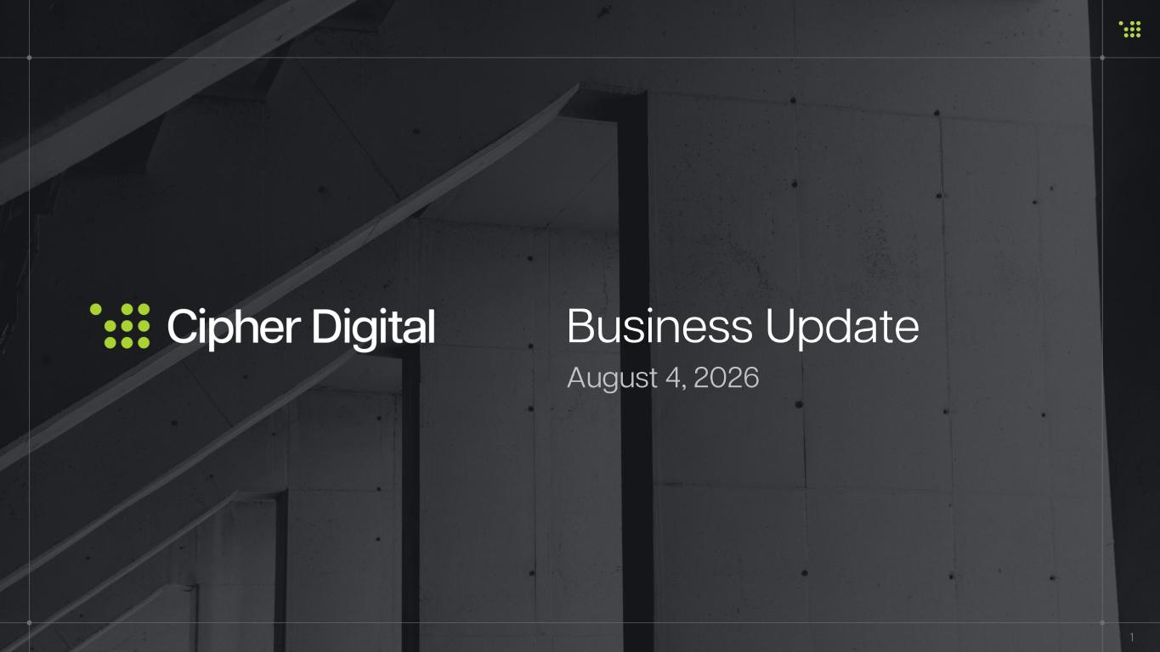

Business Update 1 August 4, 2026

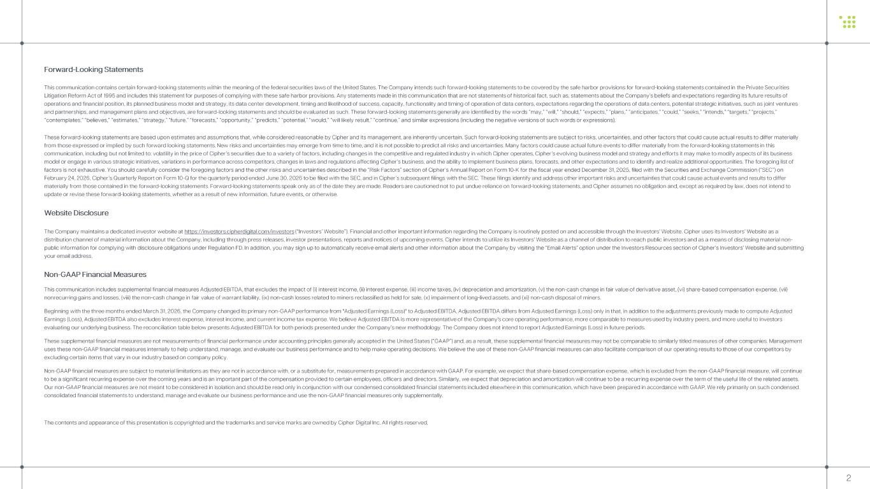
Forward -Looking Statements This communication contains certain forward -looking statements within the meaning of the federal securities laws of the United S tates. The Company intends such forward -looking statements to be covered by the safe harbor provisions for forward -looking state ments contained in the Private Securities Litigation Reform Act of 1995 and includes this statement for purposes of complying with these safe harbor provisions. Any st ate ments made in this communication that are not statements of historical fact, such as, statements about the Company’s beliefs and expectations regarding its future results of operations and financial position, its planned business model and strategy, its data center development, timing and likelihoo d o f success, capacity, functionality and timing of operation of data centers, expectations regarding the operations of data cen ters, potential strategic initiatives, such as joint ventures and partnerships, and management plans and objectives, are forward -looking statements and should be evaluated as such. These for ward - looking statements generally are identified by the words “may,” “will,” “should,” “expects,” “plans,” “anticipates,” “could ,” “seeks,” “intends,” “targets,” “projects,” “contemplates,” “believes,” “estimates,” “strategy,” “future,” “forecasts,” “opportunity,” “predicts,” “potential,” “would,” “will likely result,” “continue,” and similar expressions (including the negative versions of such words or expressions). These forward -looking statements are based upon estimates and assumptions that, while considered reasonable by Cipher and its ma nagement, are inherently uncertain. Such forward -looking statements are subject to risks, uncertainties, and other factors that could cause actual results to differ materially from those expressed or implied by such forward looking statements. New risks and uncertainties may emerge from time to time, an d it is not possible to predict all risks and uncertainties. Many factors could cause actual future events to differ material ly from the forward -looking statements in this communication, including but not limited to: volatility in the price of Cipher’s securities due to a variety of factors, incl uding changes in the competitive and regulated industry in which Cipher operates, Cipher’s evolving business model and strategy and efforts it may make to modify aspects of its business model or engage in various strategic initiatives, variations in performance across competitors, changes in laws and regulatio ns affecting Cipher’s business, and the ability to implement business plans, forecasts, and other expectations and to identify a nd realize additional opportunities. The foregoing list of factors is not exhaustive. You should carefully consider the foregoing factors and the other risks and uncertainties describe d in the “Risk Factors” section of Cipher’s Annual Report on Form 10 -K for the fiscal year ended December 31, 2025, filed with the Securities and Exchange Commission (“SEC”) on February 24, 2026, Cipher’s Quarterly Report on Form 10 -Q for the quarterly period ended June 30, 2026 to be filed with the SEC, and in Cipher’s subsequent filings with the SEC. These filings identify and address other important risks and uncertainties that co uld cause actual events and results to differ materially from those contained in the forward -looking statements. Forward -looking statements speak only as of the date they are made. Readers are cautioned not to put undue reliance on forward -looking statements, and Cipher assumes no obligation and, exce pt as required by law, does not intend to update or revise these forward -looking statements, whether as a result of new information, future events, or otherwise. Website Disclosure The Company maintains a dedicated investor website at https://investors.cipherdigital.com/investors (“Investors’ Website”). Financial and other important information regarding the Company is routinely posted on and accessible through the Investors’ Website. Cipher uses its Investors’ Website as a distribution channel of material information about the Company, including through press releases, investor presentations, rep orts and notices of upcoming events. Cipher intends to utilize its Investors’ Website as a channel of distribution to reach publ ic investors and as a means of disclosing material non - public information for complying with disclosure obligations under Regulation FD. In addition, you may sign up to automatical ly receive email alerts and other information about the Company by visiting the “Email Alerts” option under the Investors Resour ces section of Cipher’s Investors’ Website and submitting your email address. Non -GAAP Financial Measures This communication includes supplemental financial measures Adjusted EBITDA, that excludes the impact of ( i) interest income, (ii) interest expense, (iii) income taxes, (iv) depreciation and amortization, (v) the non -cash change in fai r value of derivative asset, (vi) share -based compensation expense, (vii) nonrecurring gains and losses, (viii) the non -cash change in fair value of warrant liability, (ix) non -cash losses related to mi ners reclassified as held for sale, (x) impairment of long -lived assets, and (xi) non -cash disposal of miners. Beginning with the three months ended March 31, 2026, the Company changed its primary non -GAAP performance from "Adjusted Earnin gs (Loss)" to Adjusted EBITDA. Adjusted EBITDA differs from Adjusted Earnings (Loss) only in that, in addition to the adjustm ent s previously made to compute Adjusted Earnings (Loss), Adjusted EBITDA also excludes interest expense, interest income, and current income tax expense. We believe Adjusted EBITDA is more re pre sentative of the Company's core operating performance, more comparable to measures used by industry peers, and more useful to investors evaluating our underlying business. The reconciliation table below presents Adjusted EBITDA for both periods presented under the Company’s new methodology. The Compa ny does not intend to report Adjusted Earnings (Loss) in future periods. These supplemental financial measures are not measurements of financial performance under accounting principles generally acc ept ed in the United States (“GAAP”) and, as a result, these supplemental financial measures may not be comparable to similarly t itled measures of other companies. Management uses these non -GAAP financial measures internally to help understand, manage, and evaluate our business performance and to help make operating decisions. We believe the use of these non -GAAP financial measures can also facilitate comparison of our operatin g results to those of our competitors by excluding certain items that vary in our industry based on company policy. Non -GAAP financial measures are subject to material limitations as they are not in accordance with, or a substitute for, measure ments prepared in accordance with GAAP. For example, we expect that share -based compensation expense, which is excluded from the non -GAAP financial measure, will continue to be a significant recurring expense over the coming years and is an important part of the compensation provided to certain emp loyees, officers and directors. Similarly, we expect that depreciation and amortization will continue to be a recurring expense over the term of the useful life of the related assets. Our non -GAAP financial measures are not meant to be considered in isolation and should be read only in conjunction with our cond ensed consolidated financial statements included elsewhere in this communication, which have been prepared in accordance with GA AP. We rely primarily on such condensed consolidated financial statements to understand, manage and evaluate our business performance and use the non -GAAP financial mea sures only supplementally. The contents and appearance of this presentation is copyrighted and the trademarks and service marks are owned by Cipher Digital Inc. All rights reserved. 2

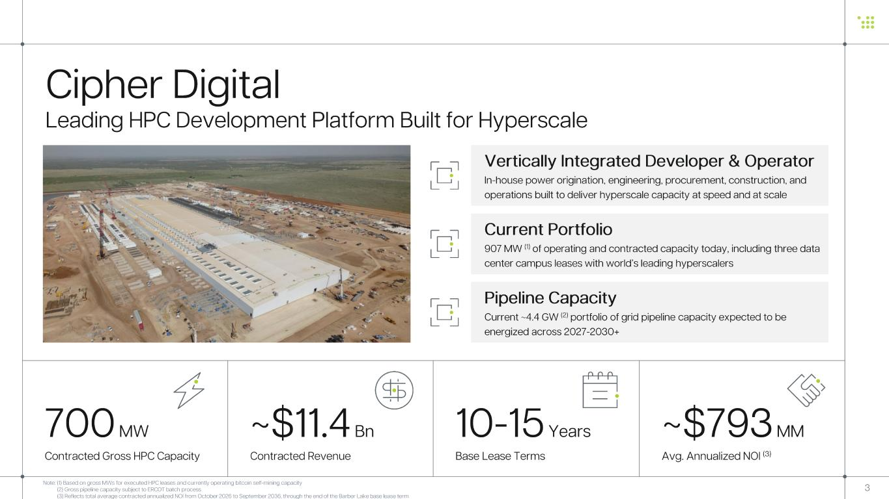
10-15 Years Base Lease Terms ~$11.4 Bn Contracted Revenue ~$793 MM Avg. Annualized NOI (3) 700 MW Contracted Gross HPC Capacity 3 Cipher Digital Leading HPC Development Platform Built for Hyperscale Note: (1) Based on gross MWs for executed HPC leases and currently operating bitcoin self -mining capacity (2) Gross pipeline capacity subject to ERCOT batch process (3) Reflects total average contracted annualized NOI from October 2026 to September 2036, through the end of the Barber Lake base lease term Current Portfolio 907 MW (1) of operating and contracted capacity today, including three data center campus leases with world’s leading hyperscalers Pipeline Capacity Current ~4.4 GW (2) portfolio of grid pipeline capacity expected to be energized across 2027 -2030+ Vertically Integrated Developer & Operator In-house power origination, engineering, procurement, construction, and operations built to deliver hyperscale capacity at speed and at scale

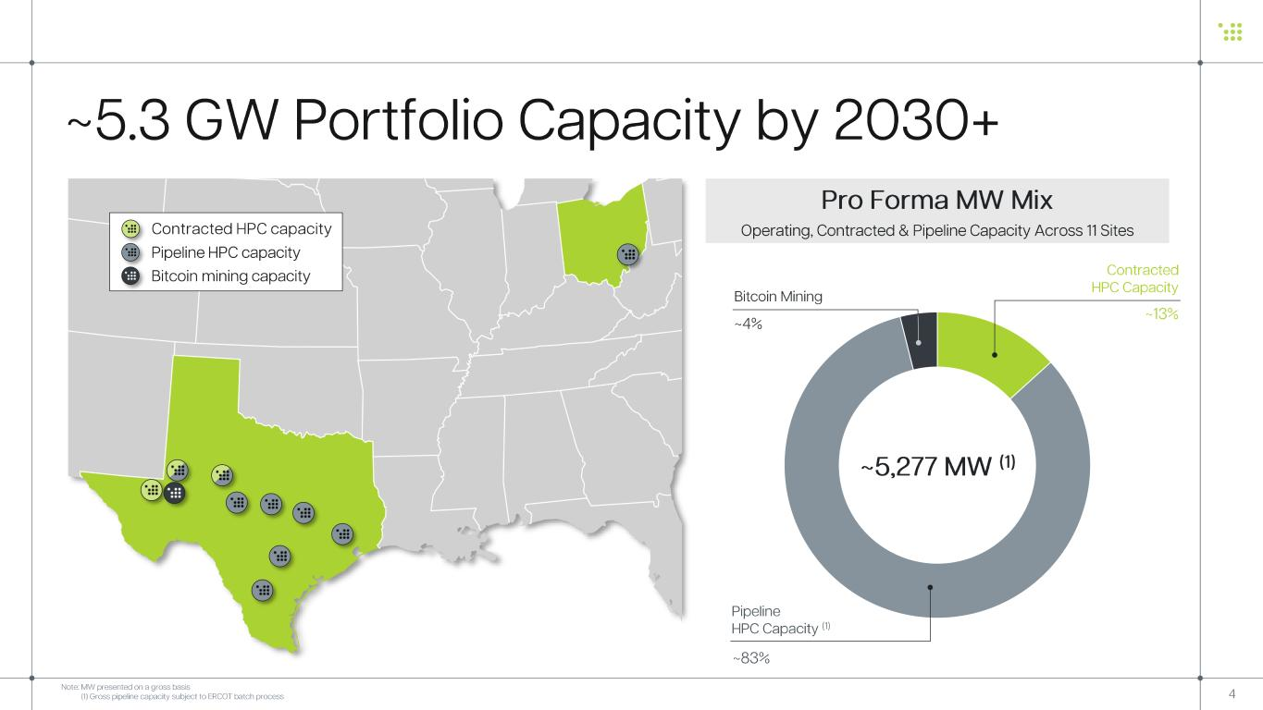
4 ~5.3 GW Portfolio Capacity by 2030+ • Contracted HPC capacity • Pipeline HPC capacity • Bitcoin mining capacity Pro Forma MW Mix Operating, Contracted & Pipeline Capacity Across 11 Sites ~13% ~83% ~4% Contracted HPC Capacity Pipeline HPC Capacity (1) Bitcoin Mining ~5,277 MW (1) Note: MW presented on a gross basis (1) Gross pipeline capacity subject to ERCOT batch process

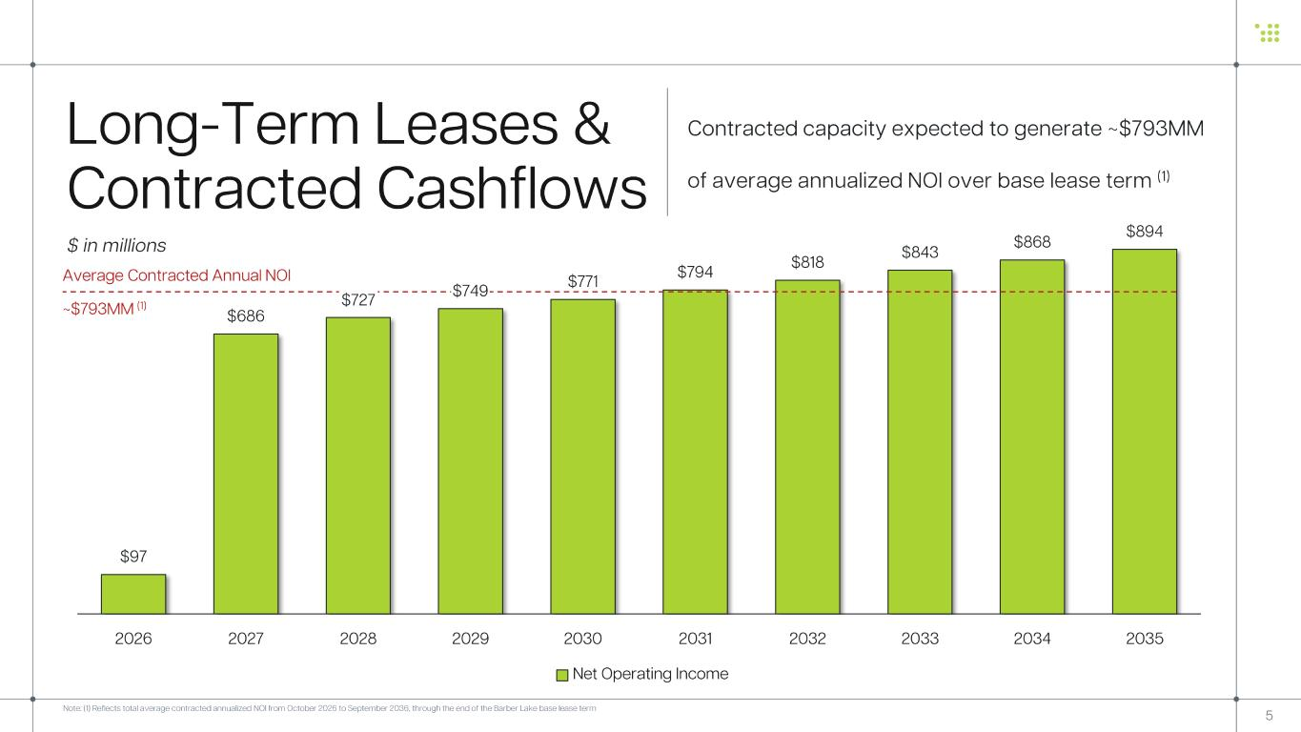
$97 $686 $727 $749 $771 $794 $818 $843 $868 $894 2026 2027 2028 2029 2030 2031 2032 2033 2034 2035 Net Operating Income 5 $ in millions Long -Term Leases & Contracted Cashflows ~$793MM (1) Average Contracted Annual NOI Contracted capacity expected to generate ~$793MM of average annualized NOI over base lease term (1) Note: (1) Reflects total average contracted annualized NOI from October 2026 to September 2036, through the end of the Barber Lake base lease term

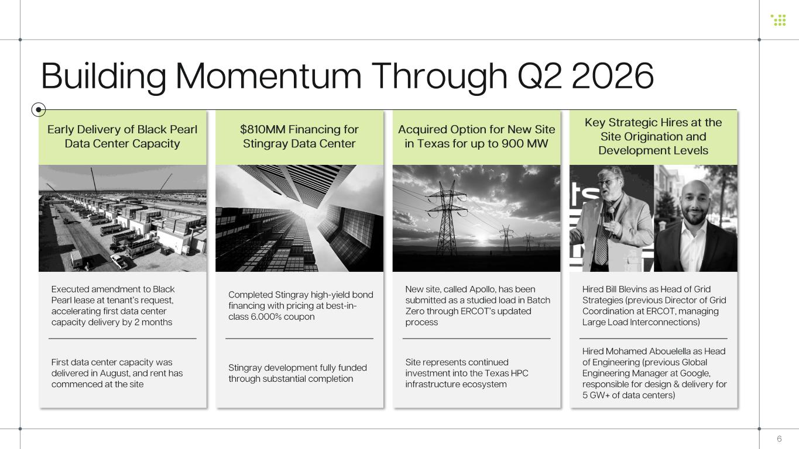
6 Building Momentum Through Q2 2026 Early Delivery of Black Pearl Data Center Capacity Key Strategic Hires at the Site Origination and Development Levels Acquired Option for New Site in Texas for up to 900 MW $810MM Financing for Stingray Data Center Executed amendment to Black Pearl lease at tenant’s request, accelerating first data center capacity delivery by 2 months First data center capacity was delivered in August, and rent has commenced at the site Completed Stingray high -yield bond financing with pricing at best -in- class 6.000% coupon Stingray development fully funded through substantial completion Hired Bill Blevins as Head of Grid Strategies (previous Director of Grid Coordination at ERCOT, managing Large Load Interconnections) Hired Mohamed Abouelella as Head of Engineering (previous Global Engineering Manager at Google, responsible for design & delivery for 5 GW+ of data centers) New site, called Apollo, has been submitted as a studied load in Batch Zero through ERCOT’s updated process Site represents continued investment into the Texas HPC infrastructure ecosystem


7 Current Portfolio

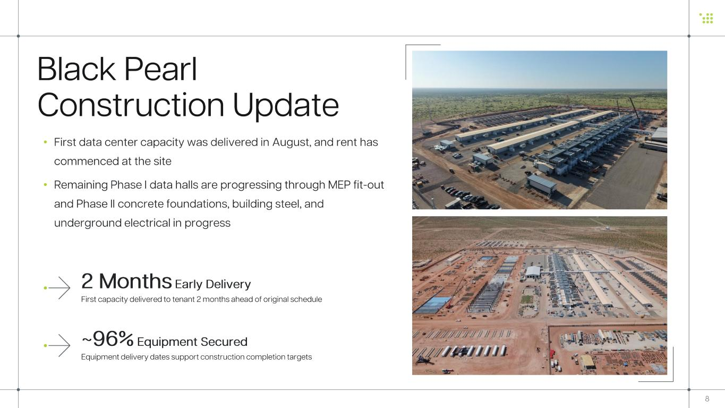
Black Pearl Construction Update 8 • First data center capacity was delivered in August, and rent has commenced at the site • Remaining Phase I data halls are progressing through MEP fit -out and Phase II concrete foundations, building steel, and underground electrical in progress ~96% Equipment Secured Equipment delivery dates support construction completion targets 2 Months Early Delivery First capacity delivered to tenant 2 months ahead of original schedule

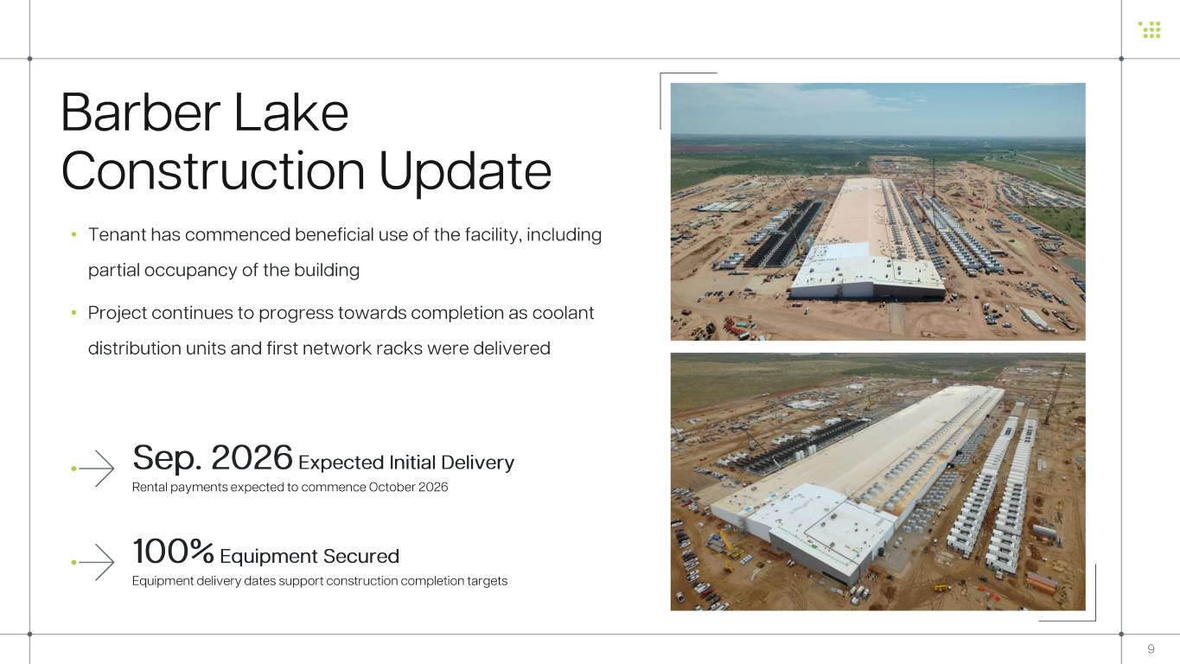
• Tenant has commenced beneficial use of the facility, including partial occupancy of the building • Project continues to progress towards completion as coolant distribution units and first network racks were delivered Barber Lake Construction Update 9 100% Equipment Secured Equipment delivery dates support construction completion targets Sep. 2026 Expected Initial Delivery Rental payments expected to commence October 2026

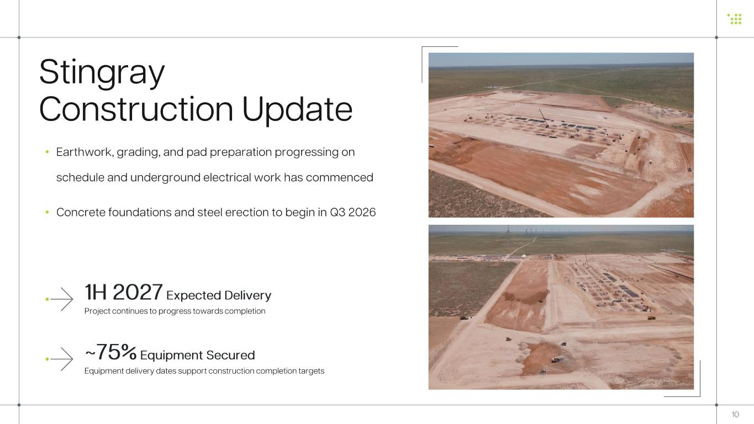
Stingray Construction Update 10 • Earthwork, grading, and pad preparation progressing on schedule and underground electrical work has commenced • Concrete foundations and steel erection to begin in Q3 2026 ~75% Equipment Secured Equipment delivery dates support construction completion targets 1H 2027 Expected Delivery Project continues to progress towards completion

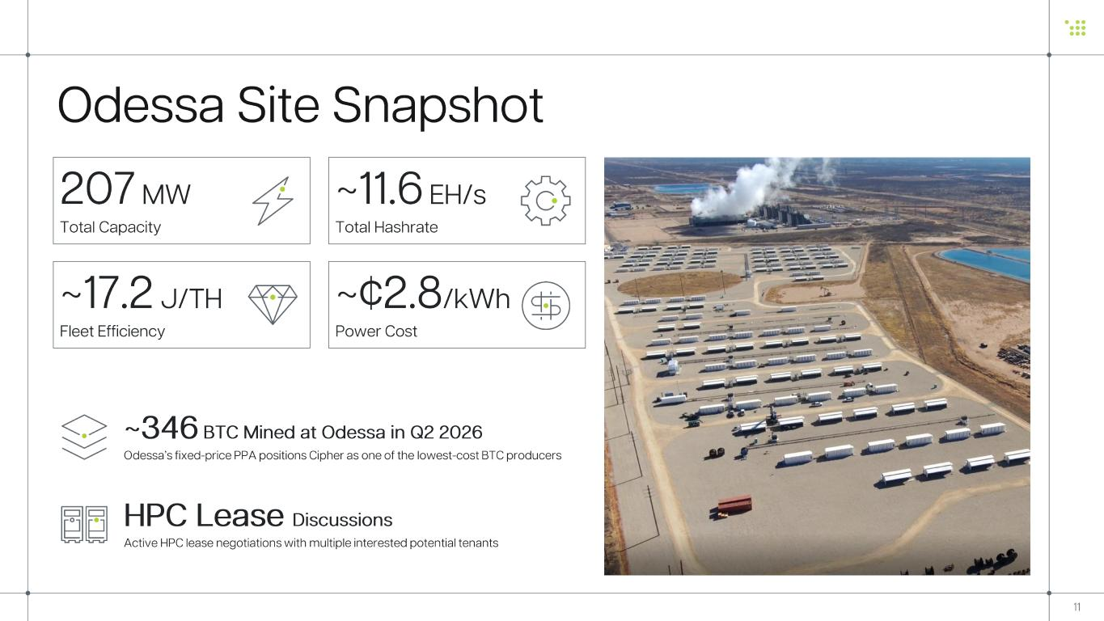
~346 BTC Mined at Odessa in Q2 2026 Odessa’s fixed -price PPA positions Cipher as one of the lowest -cost BTC producers HPC Lease Discussions Active HPC lease negotiations with multiple interested potential tenants ~11.6 EH/s Total Hashrate Odessa Site Snapshot 207 MW Total Capacity ~17.2 J/TH Fleet Efficiency ~¢2.8 /kWh Power Cost 11

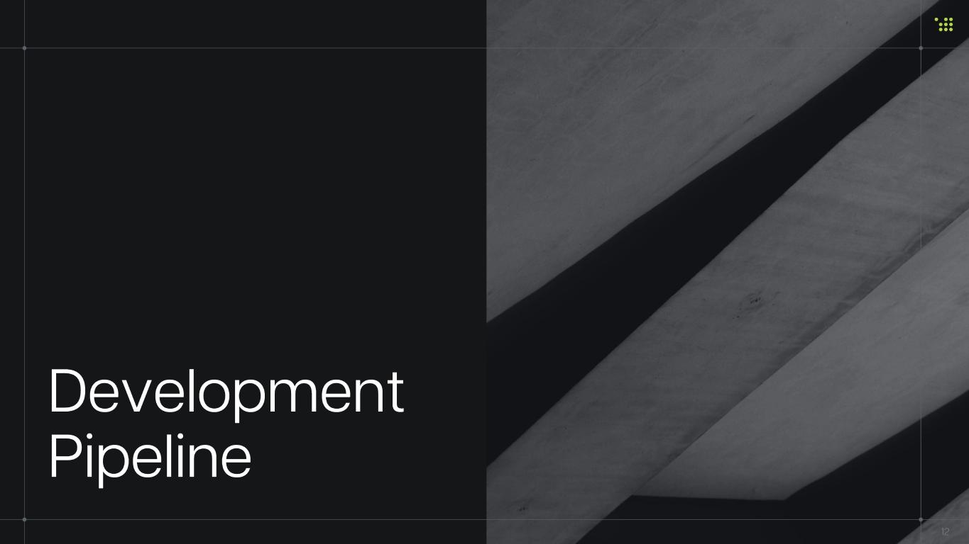
Development Pipeline 12

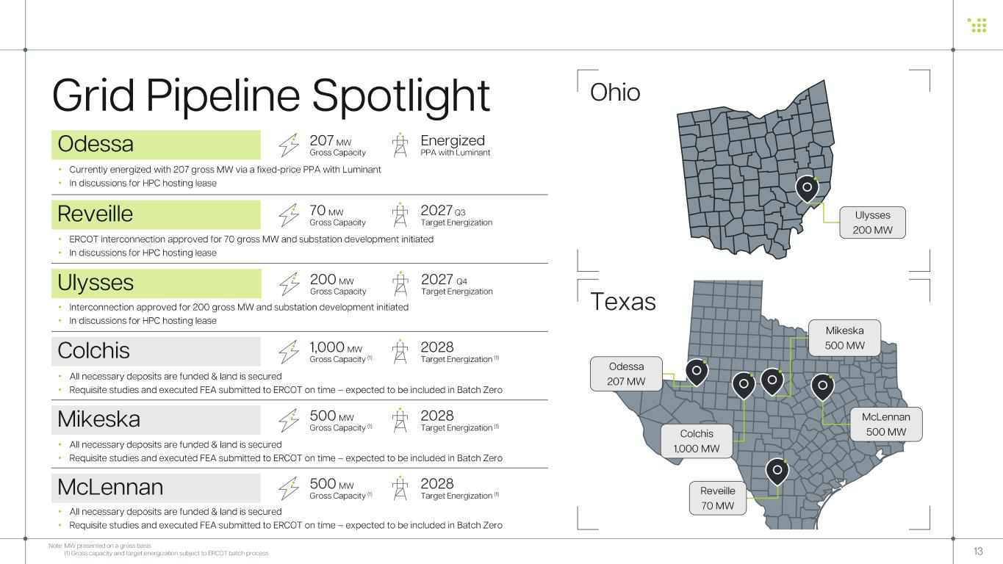
Grid Pipeline Spotlight Reveille • ERCOT interconnection approved for 70 gross MW and substation development initiated • In discussions for HPC hosting lease 2027 Q3 Target Energization 70 MW Gross Capacity Ulysses • Interconnection approved for 200 gross MW and substation development initiated • In discussions for HPC hosting lease 2027 Q4 Target Energization 200 MW Gross Capacity Colchis • All necessary deposits are funded & land is secured • Requisite studies and executed FEA submitted to ERCOT on time – expected to be included in Batch Zero 2028 Target Energization (1) 1,000 MW Gross Capacity (1) Ulysses 200 MW Ohio Texas Colchis 1,000 MW McLennan 500 MW Mikeska 500 MW Note: MW presented on a gross basis (1) Gross capacity and target energization subject to ERCOT batch process 13 Mikeska 2028 Target Energization (1) 500 MW Gross Capacity (1) • All necessary deposits are funded & land is secured • Requisite studies and executed FEA submitted to ERCOT on time – expected to be included in Batch Zero McLennan 2028 Target Energization (1) 500 MW Gross Capacity (1) • All necessary deposits are funded & land is secured • Requisite studies and executed FEA submitted to ERCOT on time – expected to be included in Batch Zero Reveille 70 MW Odessa • Currently energized with 207 gross MW via a fixed -price PPA with Luminant • In discussions for HPC hosting lease Energized PPA with Luminant 207 MW Gross Capacity Odessa 207 MW

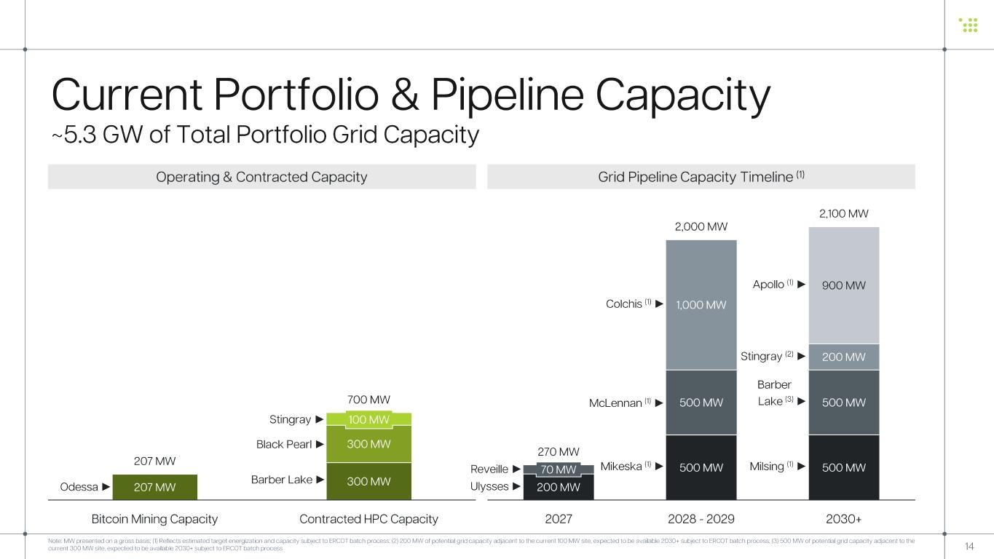
207 MW 300 MW 300 MW 100 MW 207 MW 700 MW Bitcoin Mining Capacity Contracted HPC Capacity 14 Grid Pipeline Capacity Timeline (1)Operating & Contracted Capacity Note: MW presented on a gross basis ; (1) Reflects estimated target energization and capacity subject to ERCOT batch process; (2) 200 MW of potential grid capacity adjacent to the current 100 MW site, expected to be available 2030+ subject to ERCOT batch process; (3) 500 MW of potential grid capacity adjacent to the current 300 MW site, expected to be available 2030+ subject to ERCOT batch process 200 MW 500 MW 500 MW70 MW 500 MW 500 MW 1,000 MW 200 MW 900 MW 270 MW 2,000 MW 2,100 MW 2027 2028 - 2029 2030+ Current Portfolio & Pipeline Capacity ~5.3 GW of Total Portfolio Grid Capacity Barber Lake ► Black Pearl ► Odessa ► Reveille ► Ulysses ► Mikeska (1) ► Barber Lake (3) ► Milsing (1) ► Colchis (1) ► McLennan (1) ► Stingray ► Stingray (2) ► Apollo (1) ►

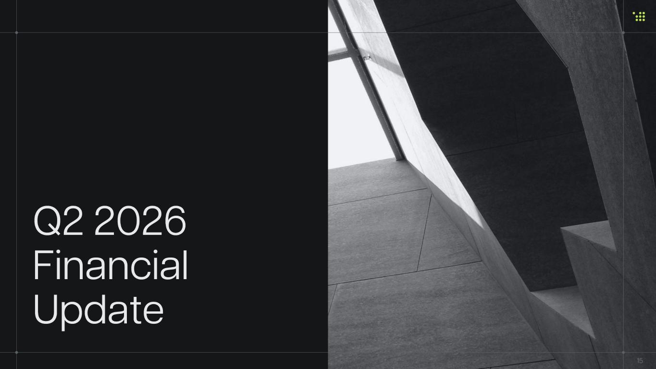
Q2 2026 Financial Update 15

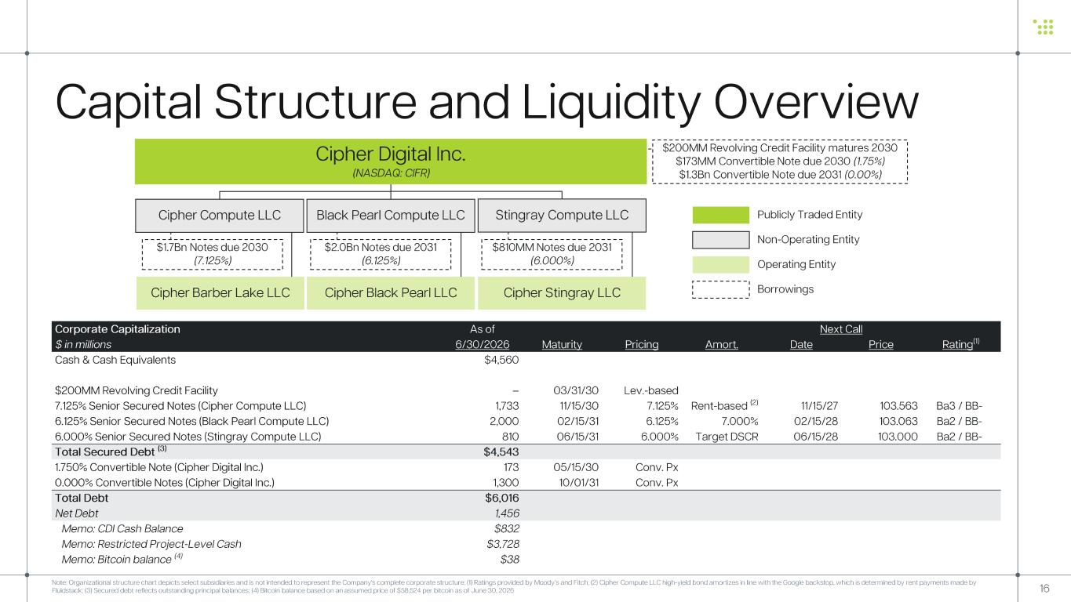
16 Capital Structure and Liquidity Overview Note: Organizational structure chart depicts select subsidiaries and is not intended to represent the Company's complete corp orate structure ; (1) Ratings provided by Moody’s and Fitch; (2) Cipher Compute LLC high -yield bond amortizes in line with the Google backstop, which is determined by rent payments made by Fluidstack; (3) Secured debt reflects outstanding principal balances; (4) Bitcoin balance based on an assumed price of $58,524 per bitcoin as of June 30, 2026 Publicly Traded Entity Operating Entity Non-Operating Entity Cipher Barber Lake LLC Cipher Black Pearl LLC Borrowings $200MM Revolving Credit Facility matures 2030 $173MM Convertible Note due 2030 (1.75%) $1.3Bn Convertible Note due 2031 (0.00%) Cipher Digital Inc. (NASDAQ: CIFR) $1.7Bn Notes due 2030 (7.125%) $2.0Bn Notes due 2031 (6.125%) Cipher Compute LLC Black Pearl Compute LLC Stingray Compute LLC Corporate Capitalization As of Next Call $ in millions 6/30/2026 Maturity Pricing Amort. Date Price Rating (1) Cash & Cash Equivalents $4,560 $200MM Revolving Credit Facility – 03/31/30 Lev. -based 7.125% Senior Secured Notes (Cipher Compute LLC) 1,733 11/15/30 7.125% Rent-based (2) 11/15/27 103.563 Ba3 / BB - 6.125% Senior Secured Notes (Black Pearl Compute LLC) 2,000 02/15/31 6.125% 7.000% 02/15/28 103.063 Ba2 / BB - 6.000% Senior Secured Notes (Stingray Compute LLC) 810 06/15/31 6.000% Target DSCR 06/15/28 103.000 Ba2 / BB - Total Secured Debt (3) $4,543 1.750% Convertible Note (Cipher Digital Inc.) 173 05/15/30 Conv. Px 0.000% Convertible Notes (Cipher Digital Inc.) 1,300 10/01/31 Conv. Px Total Debt $6,016 Net Debt 1,456 Memo: CDI Cash Balance $832 Memo: Restricted Project -Level Cash $3,728 Memo: Bitcoin balance (4) $38 Cipher Stingray LLC $810MM Notes due 2031 (6.000%)

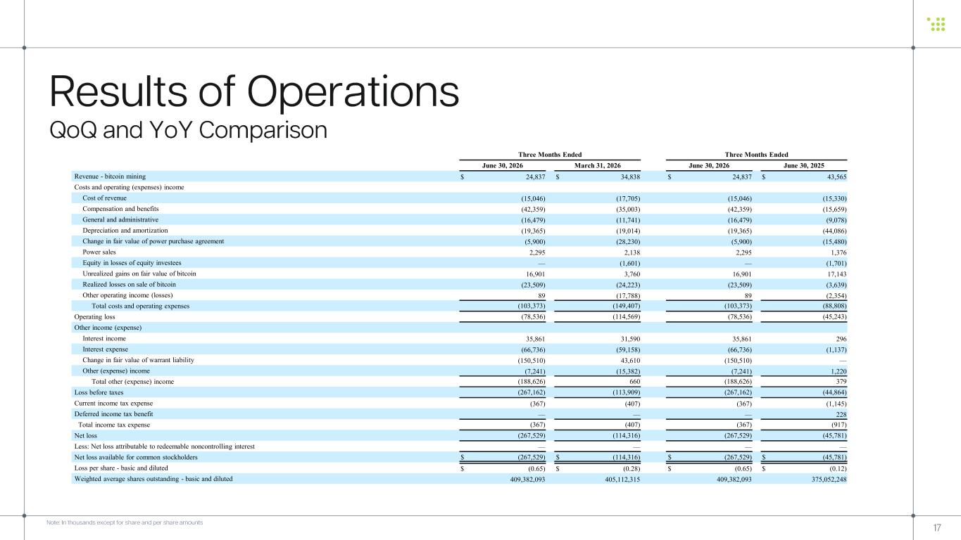
Three Months Ended Three Months Ended June 30, 2026 March 31, 2026 June 30, 2026 June 30, 2025 Revenue - bitcoin mining $ 24,837 $ 34,838 $ 24,837 $ 43,565 Costs and operating (expenses) income Cost of revenue (15,046) (17,705) (15,046) (15,330) Compensation and benefits (42,359) (35,003) (42,359) (15,659) General and administrative (16,479) (11,741) (16,479) (9,078) Depreciation and amortization (19,365) (19,014) (19,365) (44,086) Change in fair value of power purchase agreement (5,900) (28,230) (5,900) (15,480) Power sales 2,295 2,138 2,295 1,376 Equity in losses of equity investees — (1,601) — (1,701) Unrealized gains on fair value of bitcoin 16,901 3,760 16,901 17,143 Realized losses on sale of bitcoin (23,509) (24,223) (23,509) (3,639) Other operating income (losses) 89 (17,788) 89 (2,354) Total costs and operating expenses (103,373) (149,407) (103,373) (88,808) Operating loss (78,536) (114,569) (78,536) (45,243) Other income (expense) Interest income 35,861 31,590 35,861 296 Interest expense (66,736) (59,158) (66,736) (1,137) Change in fair value of warrant liability (150,510) 43,610 (150,510) — Other (expense) income (7,241) (15,382) (7,241) 1,220 Total other (expense) income (188,626) 660 (188,626) 379 Loss before taxes (267,162) (113,909) (267,162) (44,864) Current income tax expense (367) (407) (367) (1,145) Deferred income tax benefit — — — 228 Total income tax expense (367) (407) (367) (917) Net loss (267,529) (114,316) (267,529) (45,781) Less: Net loss attributable to redeemable noncontrolling interest — — — — Net loss available for common stockholders $ (267,529) $ (114,316) $ (267,529) $ (45,781) Loss per share - basic and diluted $ (0.65) $ (0.28) $ (0.65) $ (0.12) Weighted average shares outstanding - basic and diluted 409,382,093 405,112,315 409,382,093 375,052,248 17 Results of Operations QoQ and YoY Comparison Note: In thousands except for share and per share amounts

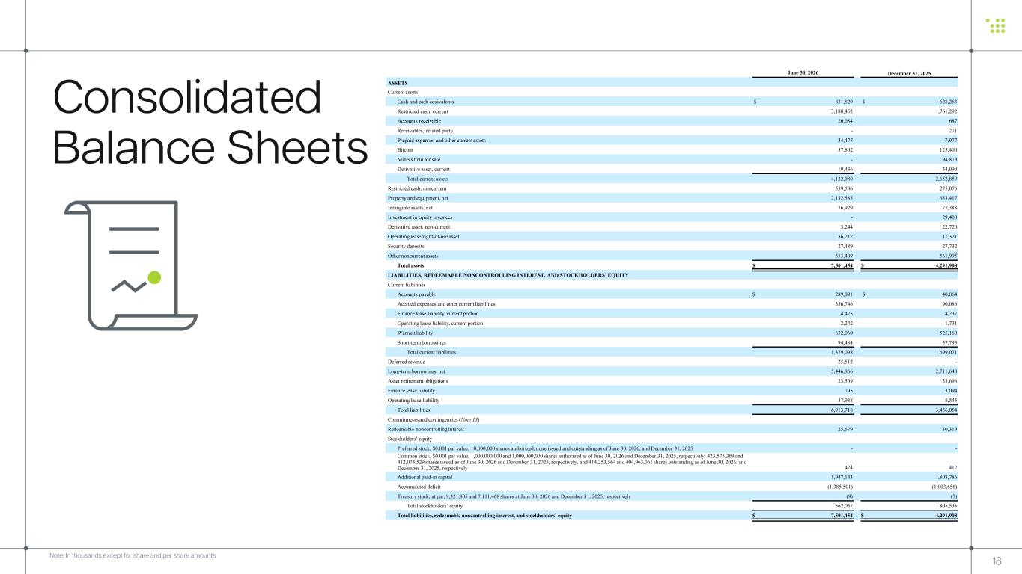
June 30, 2026 December 31, 2025 ASSETS Current assets Cash and cash equivalents $ 831,829 $ 628,263 Restricted cash, current 3,188,452 1,761,292 Accounts receivable 20,084 687 Receivables, related party - 271 Prepaid expenses and other current assets 34,477 7,977 Bitcoin 37,802 125,400 Miners held for sale - 94,879 Derivative asset, current 19,436 34,090 Total current assets 4,132,080 2,652,859 Restricted cash, noncurrent 539,506 275,076 Property and equipment, net 2,132,585 633,417 Intangible assets, net 76,929 77,388 Investment in equity investees - 29,400 Derivative asset, non-current 3,244 22,720 Operating lease right-of-use asset 36,212 11,321 Security deposits 27,489 27,732 Other noncurrent assets 553,409 561,995 Total assets $ 7,501,454 $ 4,291,908 LIABILITIES, REDEEMABLE NONCONTROLLING INTEREST, AND STOCKHOLDERS’ EQUITY Current liabilities Accounts payable $ 289,091 $ 40,064 Accrued expenses and other current liabilities 356,746 90,086 Finance lease liability, current portion 4,475 4,237 Operating lease liability, current portion 2,242 1,731 Warrant liability 632,060 525,160 Short-term borrowings 94,484 37,793 Total current liabilities 1,379,098 699,071 Deferred revenue 25,512 - Long-term borrowings, net 5,446,866 2,711,648 Asset retirement obligations 23,509 33,696 Finance lease liability 795 3,094 Operating lease liability 37,938 8,545 Total liabilities 6,913,718 3,456,054 Commitments and contingencies (Note 13) Redeemable noncontrolling interest 25,679 30,319 Stockholders’ equity Preferred stock, $0.001 par value; 10,000,000 shares authorized, none issued and outstanding as of June 30, 2026, and December 31, 2025 - - Common stock, $0.001 par value, 1,000,000,000 and 1,000,000,000 shares authorized as of June 30, 2026 and December 31, 2025, respectively, 423,575,369 and 412,074,529 shares issued as of June 30, 2026 and December 31, 2025, respectively, and 414,253,564 and 404,963,061 shares outstanding as of June 30, 2026, and December 31, 2025, respectively 424 412 Additional paid-in capital 1,947,143 1,808,786 Accumulated deficit (1,385,501) (1,003,656) Treasury stock, at par, 9,321,805 and 7,111,468 shares at June 30, 2026 and December 31, 2025, respectively (9) (7) Total stockholders’ equity 562,057 805,535 Total liabilities, redeemable noncontrolling interest, and stockholders’ equity $ 7,501,454 $ 4,291,908 18 Consolidated Balance Sheets Note: In thousands except for share and per share amounts

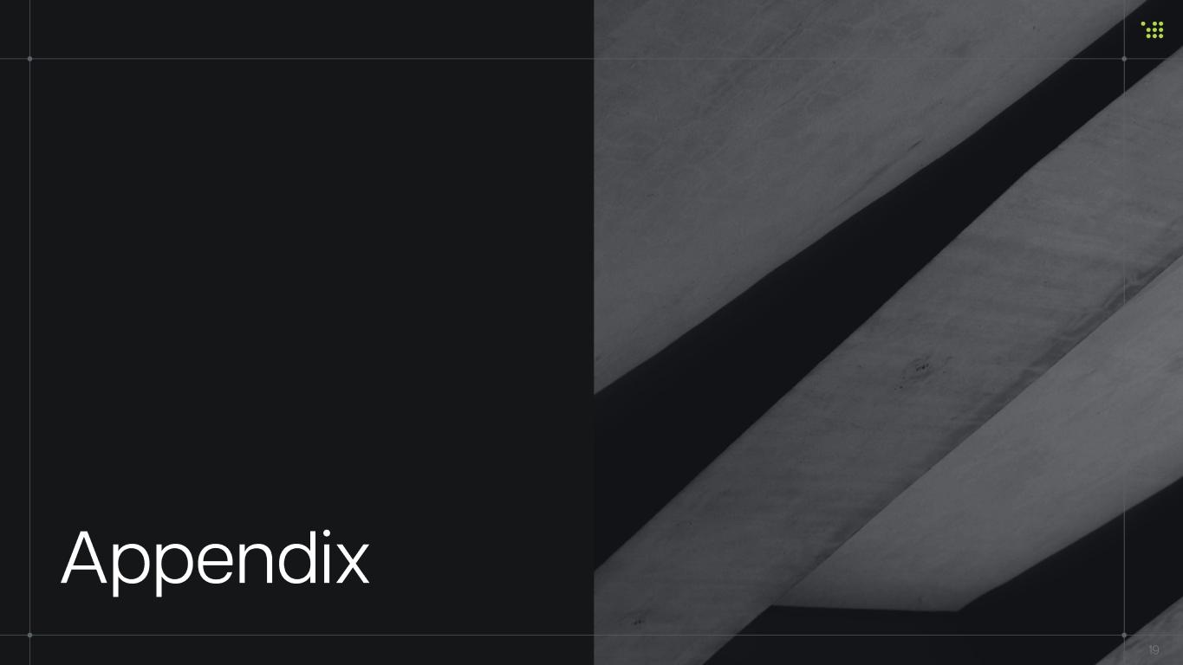
Appendix 19

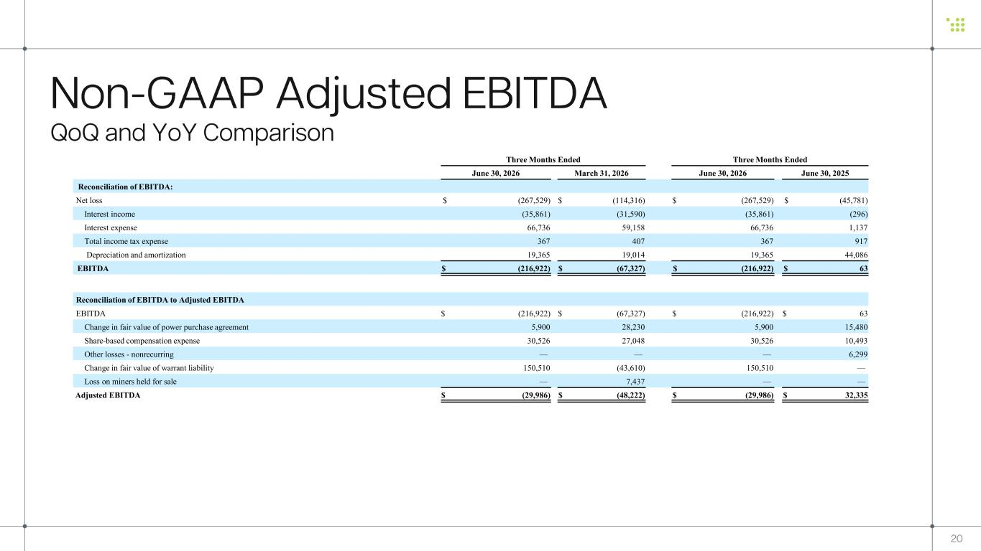
Three Months Ended Three Months Ended June 30, 2026 March 31, 2026 June 30, 2026 June 30, 2025 Reconciliation of EBITDA: Net loss $ (267,529) $ (114,316) $ (267,529) $ (45,781) Interest income (35,861) (31,590) (35,861) (296) Interest expense 66,736 59,158 66,736 1,137 Total income tax expense 367 407 367 917 Depreciation and amortization 19,365 19,014 19,365 44,086 EBITDA $ (216,922) $ (67,327) $ (216,922) $ 63 Reconciliation of EBITDA to Adjusted EBITDA EBITDA $ (216,922) $ (67,327) $ (216,922) $ 63 Change in fair value of power purchase agreement 5,900 28,230 5,900 15,480 Share-based compensation expense 30,526 27,048 30,526 10,493 Other losses - nonrecurring — — — 6,299 Change in fair value of warrant liability 150,510 (43,610) 150,510 — Loss on miners held for sale — 7,437 — — Adjusted EBITDA $ (29,986) $ (48,222) $ (29,986) $ 32,335 20 Non-GAAP Adjusted EBITDA QoQ and YoY Comparison

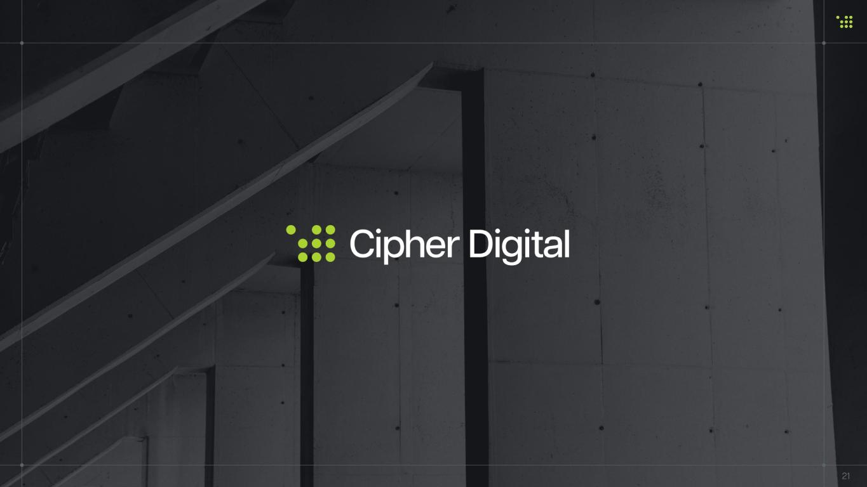
21

